000001 characteristics:

CO = 0.0008 (index rises 8 bps from opening to close)

OPC = -0.0003 (index chronically opens lower by 3 bps)

Index opens at 51 percentile and closes at 56 percentile (a gain of 5 percentile).

Shorting during the day doesn’t work in the long run.

Shorting overnight works.

Monday and Tuesdays are stronger. Monday closes at 58P and tues closes at 60P.

Implement following parameters:

1. Pm change in perc ytd
2. Max TF10 > min T F10
3. MaxF10 > prevC
4. Mon / Tue factor

Process trade strategies in xutrader, not individually in priceReceiver.

Compute delta and other parameters only once, instead of for each strategy. This saves computation time.

Going forward

1. Trade based on extreme percentile only. Put a halt to random intraday short range MA – no advantage
2. Day K levels are more reliable, due to mean reversion of percentile
3. During the day, you have an expected increase of 5P and 0.0008% of rise.
4. Hedge overnight US influences, especially during global rout

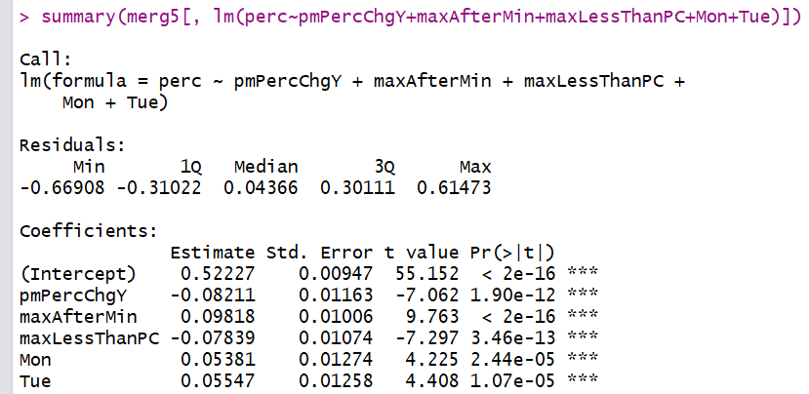

To remove hedge:

1. F10max > ytd close && f10MaxT>f10MinT